**Documentation Report – SIK Budgeting App**

**1. Purpose of the App**

The **SIK (Saving Is Key) Budgeting App** is a mobile-first finance management solution tailored for students and young adults. The app's primary purpose is to **help users build healthier financial habits** by tracking expenses, setting savings goals, and visualizing their financial behaviour over time. It does this through an intuitive interface, smart analytics, and real-time cloud data integration with Firebase.

**2. Design Considerations**

**2.1 Target Audience**

* Students and entry-level professionals
* Users new to budgeting and financial planning
* Users requiring offline and online functionality

**2.2 UI/UX Design Principles**

* **Simple Navigation**: Clear, bottom navigation bar with 5 tabs: Home, Stats, Add, Transactions, Settings.
* **Onboarding Flow**: First-time users are guided through onboarding screens after registration.
* **Dashboard-Centric**: The home screen offers quick access to all major functions.
* **Colour Scheme**: Soft tones for default, with full support for Dark and Night mode for accessibility.
* **Responsiveness**: All screens are fully responsive and optimized for various Android phone sizes using ConstraintLayout.

**2.3 App Structure**

* **Activities**:
  + MainActivity – App entry
  + LoginActivity, RegisterActivity, OnboardingActivity
  + HomeActivity – Dashboard
  + AddTransactionActivity, BudgetGoalActivity, ManageAccountsActivity, ManageCategoriesActivity
  + ProfileActivity, SettingsActivity, HelpSupportActivity
* **Adapters**: Used for RecyclerViews in transaction history, categories, and accounts
* **Utilities**: Shared functions for date formatting, currency formatting, and Firebase error handling

**3. Firebase Integration**

**3.1 Services Used**

* **Authentication**: Handles user sign-up and login securely
* **Realtime Database**: Stores and fetches all user-specific data
* **Storage**: Stores transaction receipt images

**3.2 Data Structure in Firebase**

/users

/UID

- name

- email

- currency

- budgets

- transactions

- goals

- accounts

**3.3 Firebase Configuration Steps**

1. Created Firebase Project in console
2. Added Android SHA and google-services.json to project
3. Enabled Email/Password authentication
4. Wrote Firebase rules for secure access
5. Used FirebaseAuth, FirebaseDatabase, and FirebaseStorage for all functionality

**4. GitHub Usage & CI/CD**

**4.1 Repository**

* GitHub link: <https://github.com/emmajaedunn/PROG7313_SIKBudgetingApp.git>

**4.2 Git Workflow**

* Branching used: main, dev, feature/*
* Frequent commits made with clear, descriptive messages
* Code was pushed regularly after every completed component

**4.3 GitHub Actions Setup**

* A CI workflow using GitHub Actions was created to:
  + Build the APK automatically on every push
  + Run test suites (unit tests for login, data fetch, etc.

**5. Key Features (Including Final PoE Requirements)**

**Core Requirements Met:**

* Login/Register with Firebase
* Add Transactions (with photo upload)
* View and Filter Transactions
* Manage Categories
* Manage Accounts
* Budget Tracker with min/max goals
* View Graphs by category over time
* Store all data online via Firebase
* View monthly goal progress

**Custom Features Implemented:**

**1. Multi-Currency Support**

* User selects currency during onboarding or from settings
* All amounts adapt to user’s selected currency
* Currency preference stored in Firebase and loaded dynamically

**2. Notifications and Help & Support Page**

* Custom in-app notification alerts when a user reaches or updates budget goals
* Level-up system notifies when users improve tracking habits
* Help & Support (“Fax Page”) with FAQs and contact guidance

**6. Screens Overview**

Include screenshots of the following:

1. **Login and Register** – Firebase-authenticated user management

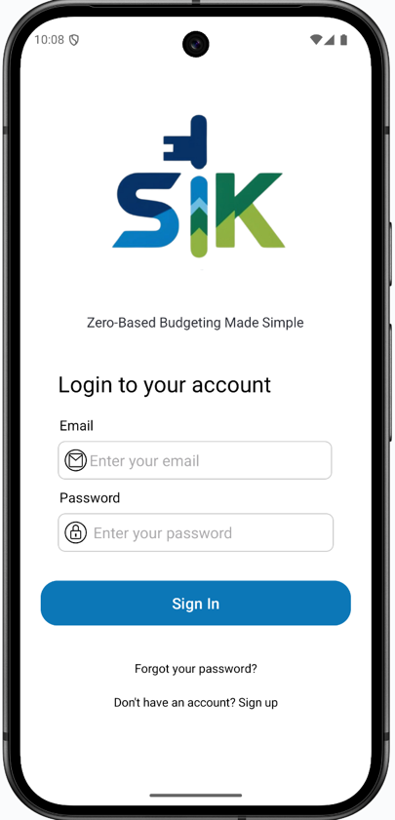

1. **Dashboard/Home Page** – Dashboard with add transaction, transaction history, analytics and settings

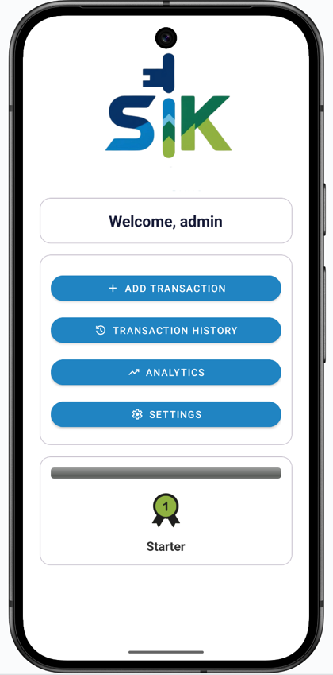

1. **Stats -** Visual analytics of money spent

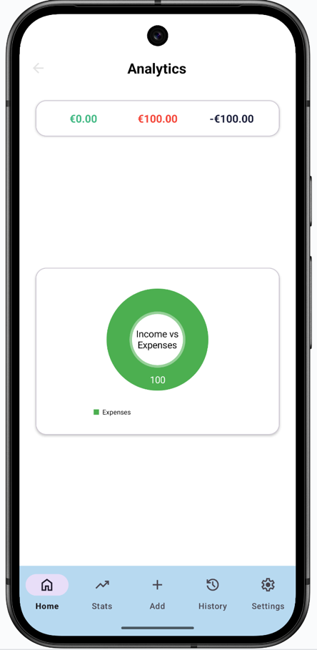

1. **Add Transaction** – Manual entry with receipt image

1. **Transaction History** – Users income and expenses

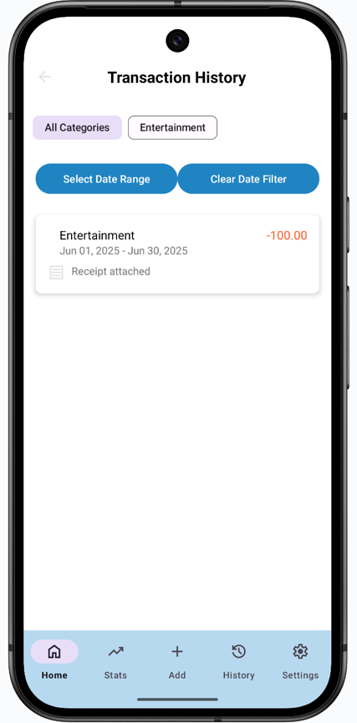

1. **Settings Page**:

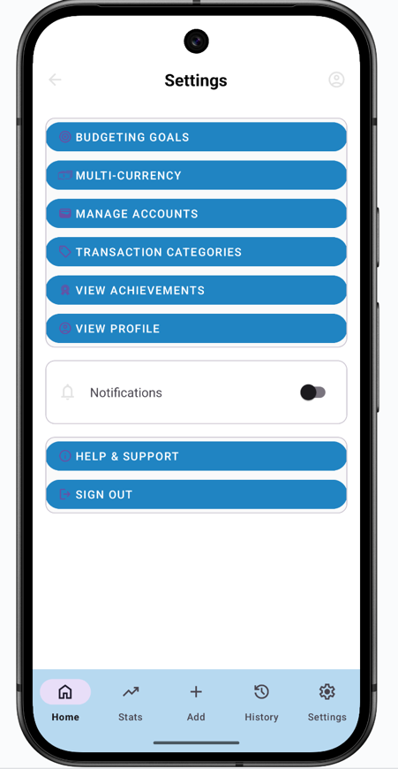

**Profile Page** – Users can view and update information

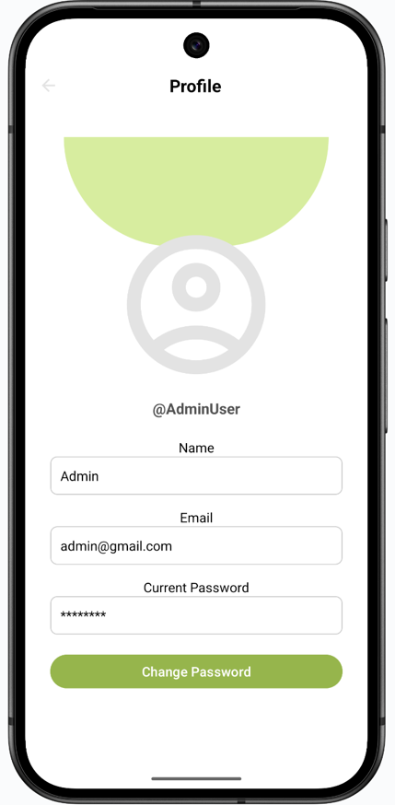

**Budget Goals** – Monthly limit settings

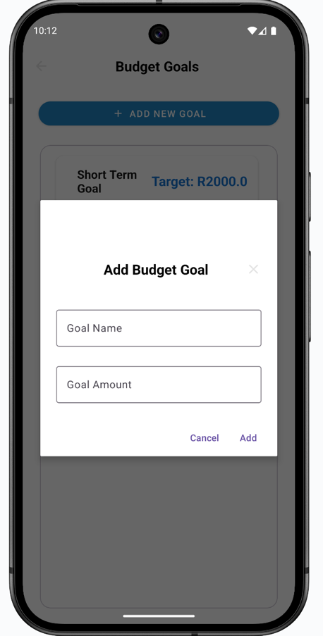

**Multi-currency** – Select your currency

**Manage Accounts** – Custom add/delete account category logic

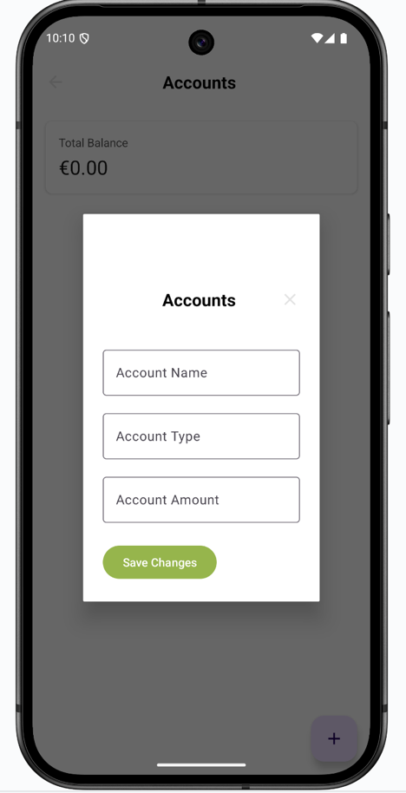

**Manage Categories** – Custom add/delete transaction category logic

**View Achievements** – Users level depending on budgeting progress



**Notifications** – Enable notification for updates and reminders

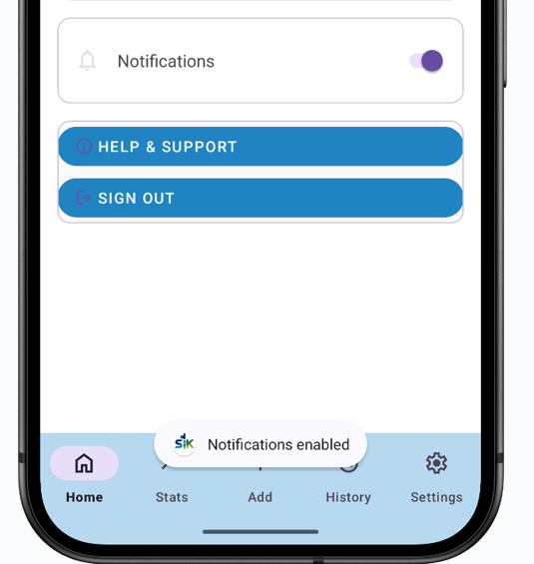

**Help & support** – Fax info section

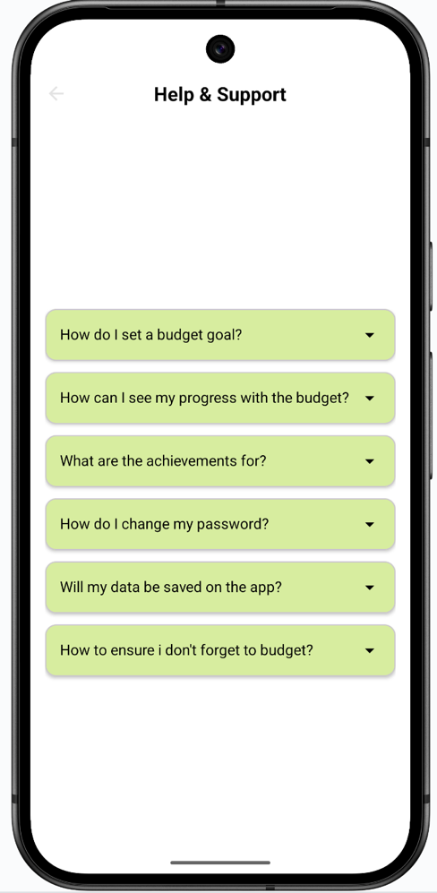

**7. Testing & Deployment**

**Testing Methods**

* Manual testing on real Android devices
* Firebase test accounts and dummy data
* Logcat used extensively for debugging
* Gradle build validation through GitHub Actions

**Final Delivery**

* Final APK tested on multiple Android versions (8.0 – 13)
* App icon and splash screens included
* No runtime crashes or Firebase sync issues observed

**10. Conclusion**

The **SIK Budgeting App** delivers a streamlined, visually appealing, and secure platform for users to take control of their financial lives. With features designed around user behavior and real-time feedback, the app meets all academic, technical, and functional requirements while offering real-world value.